

Practices for Secure Software Report

Table of Contents
Document Revision History 3
Client 3
Instructions 3
Developer 4
1. Algorithm Cipher 4
2. Certificate Generation 4
3. Deploy Cipher 4
4. Secure Communications 4
5. Secondary Testing 4
6. Functional Testing 4
7. Summary 4
8. Industry Standard Best Practices 4

Document Revision History

Version | Date | Author | Comments
1.0 | 08/12/2024 | Dominick Marquez

Client



Instructions

Submit this completed practices for secure software report. Replace the bracketed text with the relevant information. You must document your process for writing secure communications and refactoring code that complies with software security testing protocols.

- Respond to the steps outlined below and include your findings.
- Respond using your own words. You may also choose to include images or supporting materials. If you include them, make certain to insert them in all the relevant locations in the document.
- Refer to the Project Two Guidelines and Rubric for more detailed instructions about each section of the template.

Developer
Dominick Marquez

Algorithm Cipher
Given Artemis Financial’s security vulnerabilities, I recommend using AES (Advanced Encryption Standard) with a 256-bit key length. By utilizing AES-256, the risk of a successful brute-force attack within a reasonable timeframe is significantly reduced. A secure hash function like SHA-256 is also important. When used in conjunction with AES, they can provide reliable data integrity checks. 256 bits is significant because it refers to the length of the encryption key used in the cypher. In AES, the key length determines the number of possible key combinations and the overall security of the encryption. Choosing a strong hash function like SHA-256 with a high output size (typically 256 bits) complements a strong encryption algorithm with a high bit level key. The SHA-256 algorithm also uses Java's random number generation to ensure that each encrypted file is as secure as possible. Random number generation is also crucial for encryption. Secure random numbers ensure unpredictable encryption patterns. This is important since AES is a symmetric cipher, which means a single key is used for both encryption and decryption. Encryption algorithms have come a long way from simple substitution ciphers of ancient civilizations. They are continuously evolving. Not one algorithm cipher is the best. This means we must continue to research and refine encryption algorithms to stay ahead of new threats.

Certificate Generation
Insert a screenshot below of the CER file.

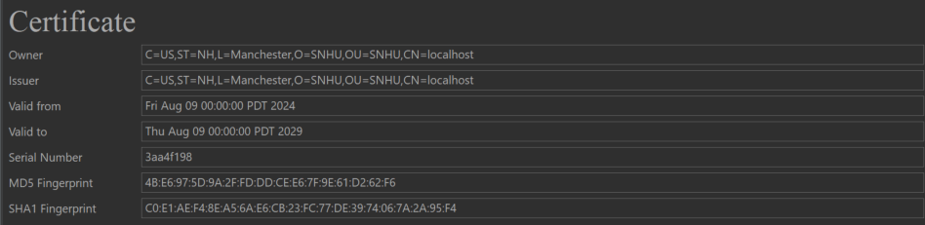

Deploy Cipher
Insert a screenshot below of the checksum verification.

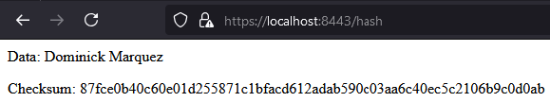

Secure Communications
Insert a screenshot below of the web browser that shows a secure webpage.



Secondary Testing
Insert screenshots below of the refactored code executed without errors and the dependency-check report.

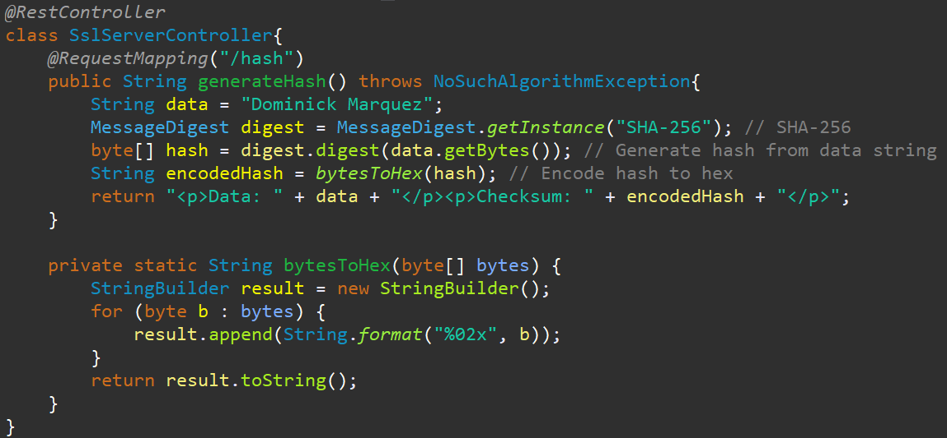
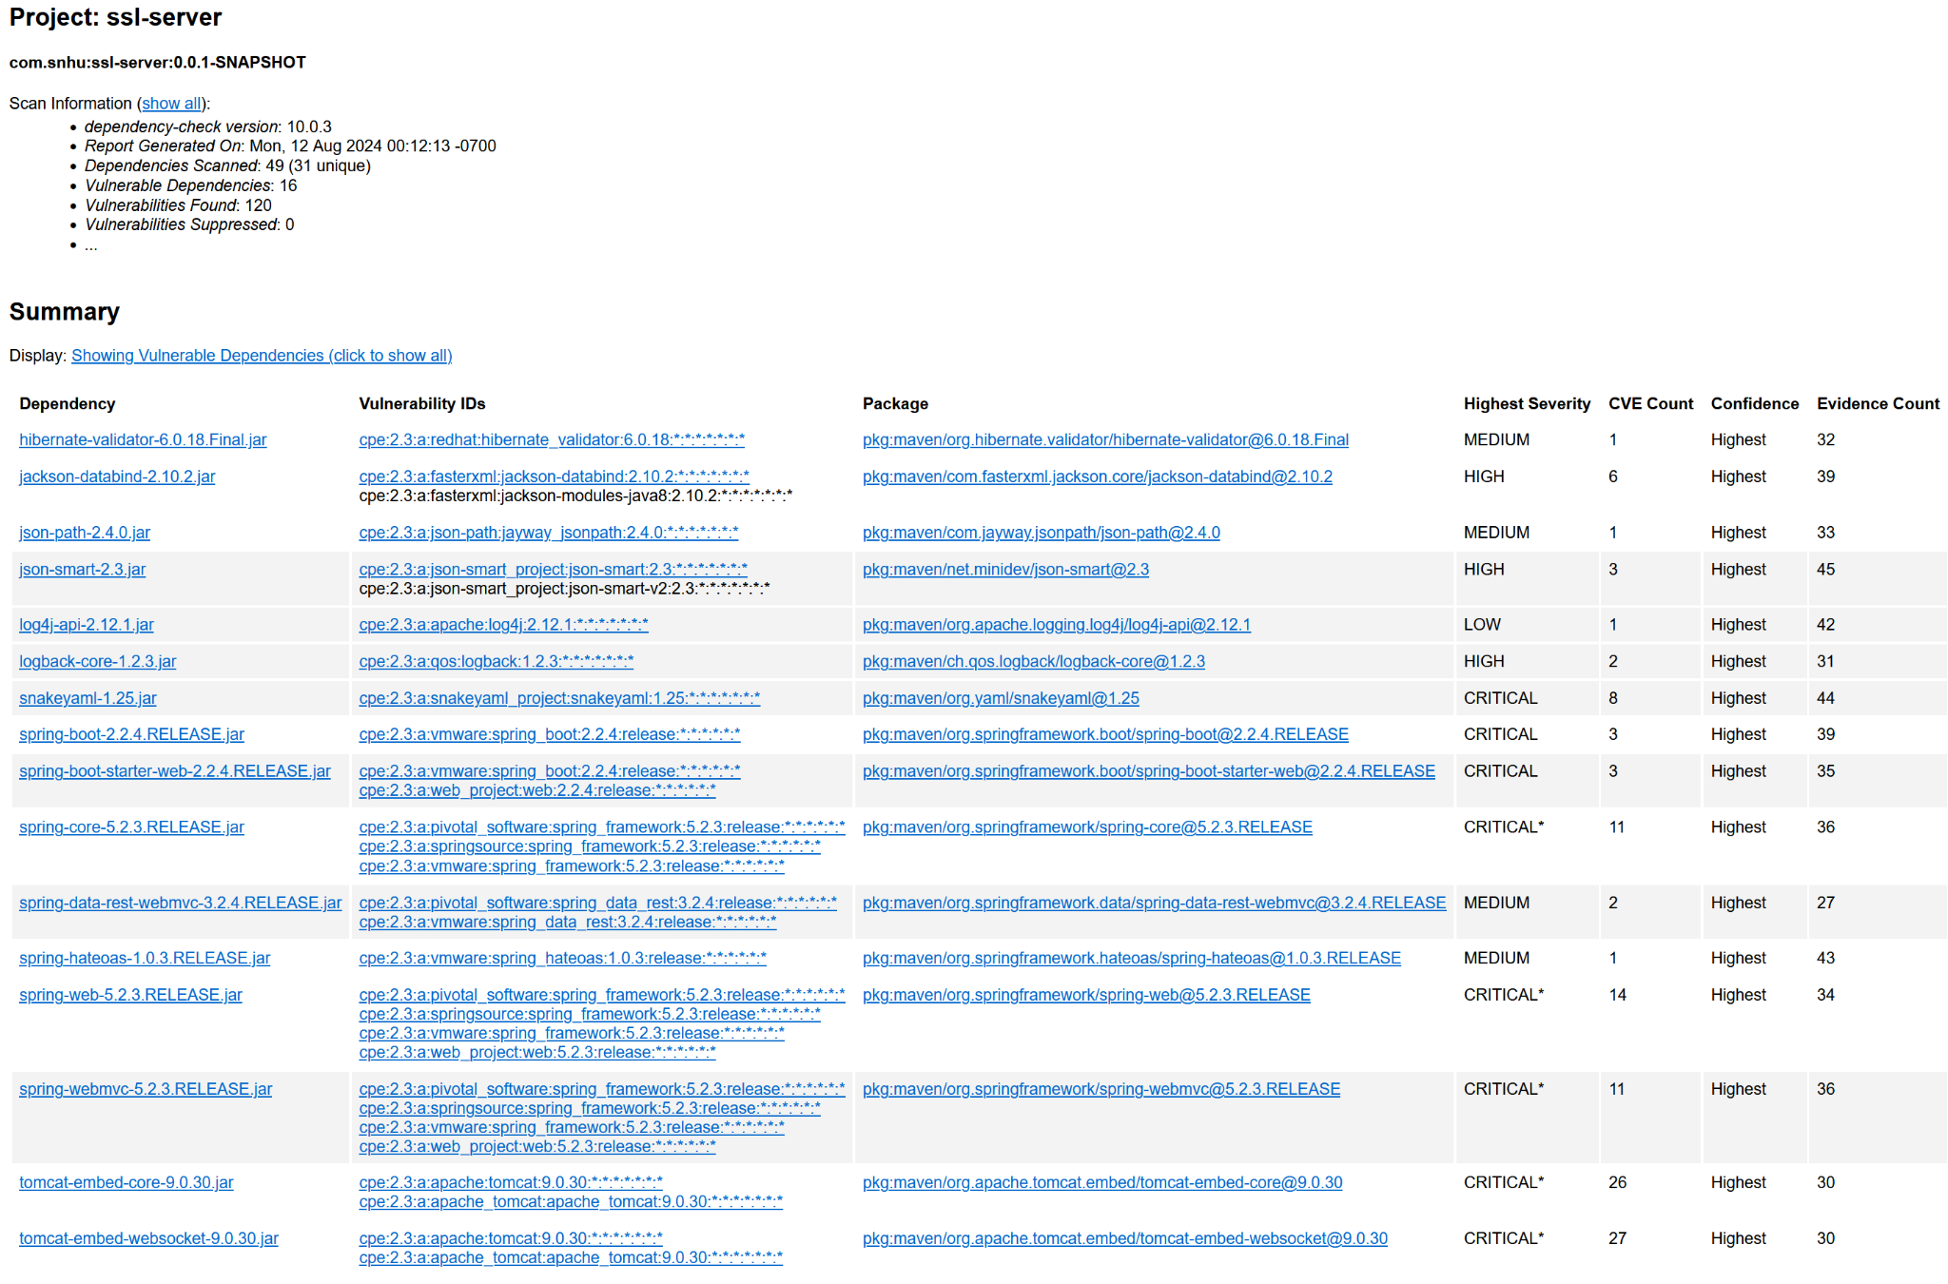

Functional Testing
Insert a screenshot below of the refactored code executed without errors.

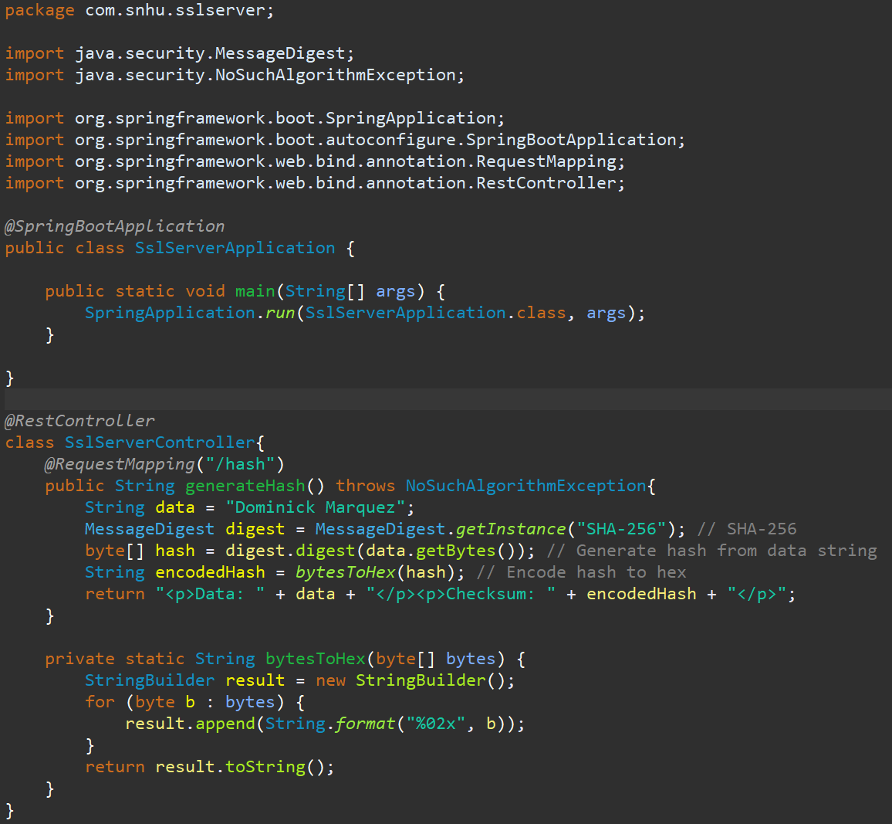

Summary

The refactored code aligns with a secure architecture by using a well-defined controller structure and encapsulating sensitive logic. It demonstrates a foundation for secure practices. The @RequestMapping annotation defines the API endpoint, ensuring that only authorized requests can access the generateHash method. The use of SHA-256 for hashing demonstrates strong cryptographic practices. While the code doesn't explicitly handle client-server communication, the use of a secure hashing algorithm helps protect data transmitted between the client and server. The NoSuchAlgorithmException is explicitly handled, demonstrating proper error handling. This improves the robustness of the code and reduces the risk of vulnerabilities that might arise from unexpected conditions. The refactored code is well-structured and readable, adhering to secure coding practices. Finally, The bytesToHex method is private, encapsulating sensitive logic and preventing unauthorized access. The refactored code demonstrates security best practices that align with the vulnerability assessment process flow diagram.

Industry Standard Best Practices
To maintain the software application's existing security, I've applied industry standard best practices such as:
- OWASP Top 10: By addressing vulnerabilities like injection, cross-site scripting, and sensitive data exposure, the refactored code aligns with the OWASP Top 10 list of most critical web application security risks.
- Secure Coding Practices: The code adheres to principles like input validation, output encoding, and error handling, which are fundamental for preventing common vulnerabilities.
- Cryptography: The use of a strong hashing algorithm like SHA-256 ensures data integrity and protects against unauthorized access.
Applying industry standard best practices for secure coding offers significant value to the company's overall well-being:
- Risk Mitigation: By following these practices, the company can reduce the risk of security breaches, data leaks, and financial losses.
- Customer Trust: A secure application helps build trust with customers, leading to increased customer satisfaction and loyalty.
- Regulatory Compliance: Adhering to industry standards can help the company comply with relevant regulations and avoid legal issues.
- Operational Efficiency: Secure coding practices can improve the application's reliability and reduce the need for costly security remediation efforts.

